August 30, 2023
Ref: IIH/MD/2023/08/010

His Excellency,
The Executive Governor of Kwara State,
Government House,
Ahmadu Bello Way,
GRA, Ilorin, Kwara State

Your Excellency Sir,

REQUEST FOR APPROVAL FOR FREE DIGITAL MARKETING TRAINING
FOR 2000 KWARA YOUTH
I write to request approval to hold a free two-day Digital Marketing Training that will be open to 2000 youth of Kwara State at the Kwara State Banquet Hall on November 3-4 2023. This two-day training will equip 2000 Kwara youth with the following skills:

- Social media marketing
- Search engine optimization (SEO)
- YouTube Automation
- Email Marketing & Lead Generation
- Content Development
- Customer Research
- Community Management
- Affiliate Marketing
- Blogging
- Online Freelancing

I would like to request for a waiver of the daily rental fee for the venue and release of funds for logistics support for the training session, which is being facilitated for free by our partners. The training originally costs N40,000 per head but the partners are willing to offer this for free to Kwara State youth as a way of giving back to the state. The training also comes at no cost to the participating students, who will be given a certificate of completion at the end.

SN | DESCRIPTION | PRICE (N)*
1 | Diesel for 2-days | 200,000
2 | Snacks & refreshments | 2,000,000
 | GRAND TOTAL | 2,200,000

Yours sincerely,
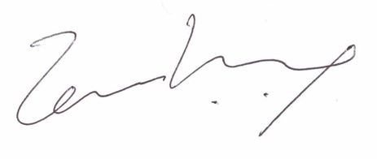
Temi Kolawole
ag. Managing Director

